**VIRTUAL FINANCE AGENT**

“A Financial Analytics tool’

***Project Proposal***

S. M. Mamdudur Rahman(151014067)

Md. Fazlay Rabbi(151014047)

Mir Md. Maksudul Alam(151014065)

Farzana Anwer(151014048)

***Instructor:***  Mr. Rakib Hossain

*Submitted in partial fulfillment of the requirements of a Software Engineering course project

7th November 6, 2018

**

# PREFACE

*This is a proposal for “Virtual Finance Agent”. Project for partial fulfillment of the requirements of a Software Engineering course project in Computer Science and Engineering department at University of Liberal Arts Bangladesh.*

*This proposal provides the scope and context of the project to be undertaken. It details the intended user group and the value that the system will have to them. It also provides a schedule for the completion of the project, including a list of all the deliverables and presentations required.*

*The intended audience of this document is the course faculty so that they can determine whether the project should be approved as proposed, approved with modifications, or not approved.*

# Table of Contents

**CHAPTER TITLE PAGE**

**COVER PAGE…………………………………………………….i**

**PREFACE………………………………………………………….ii**

**1.0 OVERVIEW……………………………………………………….**1

1.1 Purpose, Scope and Objectives **…………………………….**1

1.1.1 Purpose **……………………………………………..**1

1.1.2 Scope **……………………………………………….**1

1.1.3 Objectives **…………………………………………..**1

1.2 Project Description **…………………………………………**1

1.3 Team Profile **………………………………………………..**2

1.4 Assumptions and Constraints **………………………………**2

1.5 Project Deliverables **………………………………………..**3

1.6 Schedule and Budget Summary **……………………………**3

1.6.1 Schedule**………………………………………………**3

1.6.2 Budget Summary**……………………………………..**4

**2.0 REFERENCE ……………………………………………………..4**

**3.0 DEFINITIONS ……………………………………………………4**

**4.0 PROJECT ORGANIZATION …………………………………...5**

**5.0 CONCLUSION …………………………………………….……..5**

1. ***Overview***

1.1.1. Purpose

The target is to build a desktop-based application which is 100% focused on research and analytics. It will empower the Bangladeshi NEW capital market investors as well as the reputed bankers to do self-research by providing all necessary tools which are relevant for doing fundamental research, technical research in a very SIMPLE TO UNDERSTAND framework.

1.1.2. Scope

Companies are increasingly shifting towards automation tools that can help investors gain insight about the companies that they want to invest. A data driven desktop application system that can act as a virtual financial agent to help the investors to take optimal decision by quantifying company’s performance, balance-sheet records, ratio analysis, PE Ratio and other parameters. This project is interesting from a technical point of view as it involves JavaFX development, implementing Deep Learning approach, developing a GUI, implementing a database to track information about company’s annual reports. This project would use Java and SQL.

1.1.3. Objectives

The “Virtual Finance Agent” software lets you explore and analyze Bangladesh public company high-level financial reports automatically extracted from the back-end database, including the ability to compare financial data between 2 companies. You can search by company name and view the financial reports of the last four quarters or last four years as well as charts of annual or quarterly data reaching back several years. In addition, various financial ratios, such as current ratio, quick ratio, cash ratio, gross profit margin, operating profit margin, return on assets, return on equity, debt/equity ratio, capitalization ratio, asset turnover, free cash flow, and many others, are calculated and displayed for the last four quarters or last four years. This makes the software very useful for education purposes, such as business school programs in the area of accounting, finance, or corporate management.

1.2. **Project Description**

Bangladeshi public companies are required to file their financial reports - including income statements, balance sheets, and cash flow statements - quarterly and annually with the Dhaka Stock exchange (DSE). The financial reports provide a snapshot of the financial health of a corporation and any investor interested in fundamental analysis will typically be looking at these reports. The software would include a GUI, a database to keep track of all these information about the company’s reports to implement the various functions of the system. For example, this would include the following functions to measure a company’s overall performance:

* Fundamental review
* Detailed Results Quarterly/Semiannual/Annual with interactive graphs comparison
* Ratio Analysis
* Return Ratios
* Efficiency Ratios
* Growth Ratios
* Solvency Ratios
* Cash Flow Ratios
* Valuation Ratios
* Interactive Balance Sheet
* Profit and Loss statement
* Cash Flow Statement
* Shareholding Pattern
* Major Shareholders since last 5 years.

1.3. **Team Profile**

* S. M. Mamdudur Rahman(12th semester)

Expertise: JavaFX, algorithm Design, OOP, MySql , Software Architecture

Role: Planning, coordinating members, Developing Software

* Mir Md. Maksudul Alam(12th semester)

Expertise: Database, Java OOP, UML Diagrams, data analysis

Role: Information gathering, Database design, cooperating

* Md. Fazlay Rabbi(12th semester)

Expertise: Database, Java, Data structure

Role: Information gathering, Testing and evaluating

* Farzana Anwer(12th semester)

Expertise: C++, OOP, Shell Programming

Role: Designing Front-end, deployment

1.4. **Assumptions and constraints**

The two biggest challenges to developing the project would be gathering and managing related data from authentic source using a database and applying deep learning approach into the system in general. Both of these are issues of not necessarily having learned the related concepts. Both of these risks can be mitigated by ensuring to get familiar with the concept enough to work on that part of it, or by having expertise from experts who can ensure that we can learn the concepts in a timely enough manner to complete the project on schedule.

1.5. **Project Deliverables**

* Software Project Proposal: A project proposal is a detailed description of a series of activities aimed at solving the project.
* Disclaimer: This software has no control or no quality check over the information provided by the authentic source and cannot guarantee the sequence, accuracy, or completeness of any information or data from the source.

1.6.1 **Scheduling**

**GANTT chart**

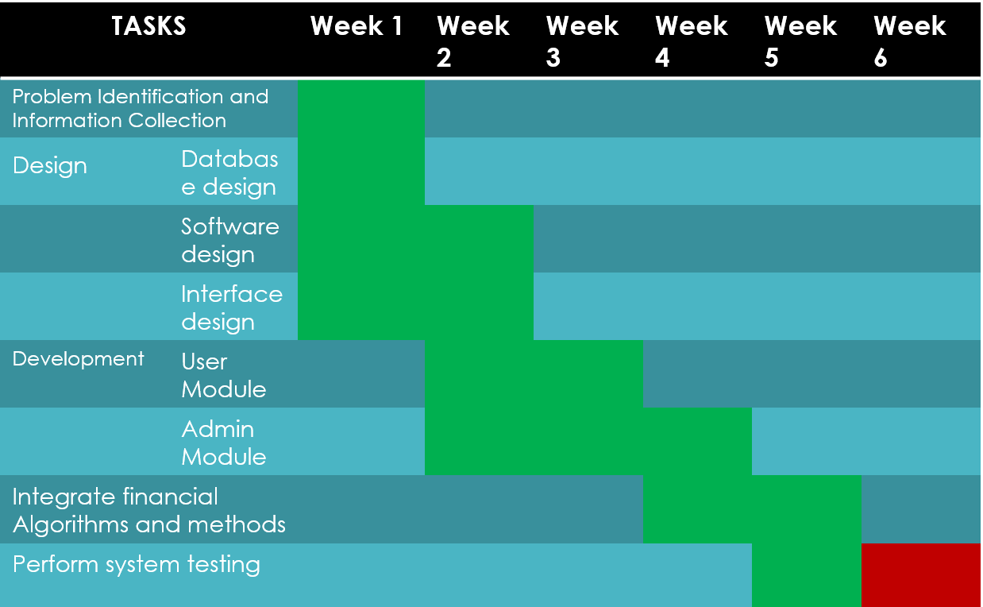

1.6.2 **Budget Summery**

* No budget required since we are using our own infrastructures and open source data.

**2.0. *References***

* S. Gad, “How To Efficiently Read An Annual Report,” *Investopedia*, 15-Nov-2015. [Online]. Available: https://www.investopedia.com/articles/basics/10/efficiently-read-annual-report.asp?fbclid=IwAR06Gi1GQm3CEnu40lt5iupWHlYi8NeEvwCfw8URhDDpXuZP5IGc7N0lNig. [Accessed: 06-Nov-2018].
* K. Languedoc, “How to Write a Software Development Proposal,” *ToughNickel*, 26-Oct-2018. [Online]. Available: https://toughnickel.com/business/How-to-Write-a-Software-Development-Proposal. [Accessed: 06-Nov-2018].
* A. Consulting, “Software Project Budget,” *Determining the budget for a new software project*. [Online]. Available: https://www.axia-consulting.co.uk/html/project_budget.html?fbclid=IwAR14nbbf-c-rfNIveEjEwO0Lsxe9PKXOoi5MTD8Uq1i3OoUlOSVR3TXajmo. [Accessed: 06-Nov-2018].

**3.0 *Definitions***

* Ratio Analysis: A form of Financial Statement Analysis
* Return Ratios : profitability ratio that measures the net income produced by total assets
* Efficiency Ratios : indicates the expenses as a percentage of revenue
* Growth Ratios : the company's expected growth
* Solvency Ratios : measures the extent to which assets cover commitments for future payments, the liabilities
* Valuation Ratios : compares the current price of company's shares to the amount of earnings it generates
* Cash Flow Statement : indicates how the money is moving through the company

**4.0 *Project Organization***

|  |  |
| --- | --- |
| **Person** | **Rational Unified Process Role** |
| S. M. Mamdudur Rahman | Project Manager Deployment Manager Software Architect System Analyst Change Control Manager |
| Md. Fazlay Rabbi | Project Reviewer Requirements Reviewer  Test Manager |
| Mir Md. Maksudul Alam | Requirements Specifier User Interface Designer Design Reviewer  Test Analyst |
| Farzana Anwer | Designer Integrator Test Designer Technical Writer |

**5.0. *Conclusion***

We will design and implement the software, providing analytical tools for the investors and researchers through the creation of a database and the utilization of multi-dimensional modeling software. By accomplishing these tasks, we want users to come to a better understanding of financial reports and related aspects.